**College Management System**

Agenda for the application:

The following Application is useful to provide the basic information about the training and placement cell of GITAM university Hyderabad campus and it is also useful for the institution for several activities like:

1. To get the feedback from the people
2. To make people to sign on to their website
3. To provide several facilities regarding their institution to others by giving access to people by their login page.

Data to be captured:

1. Name
2. Telephone number
3. Email id
4. Date of birth
5. Branch
6. College Pin No

**The following data is captured from the students of GITAM for giving access to their site.**

**Uml Diagrams:**

**Class diagram:**The class diagram is the main building block of object-oriented modelling. 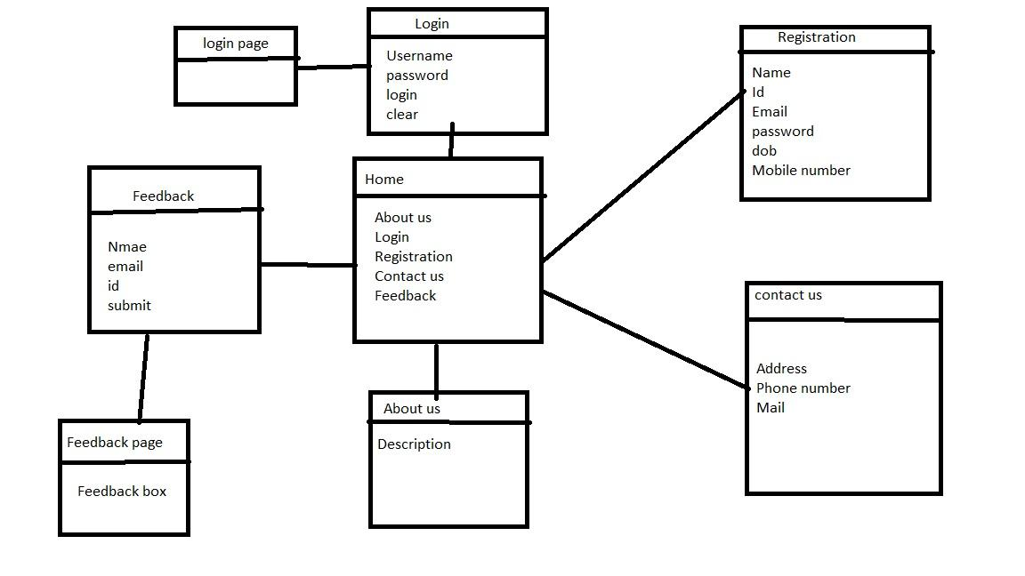

**Classes in above diagram are:**

1. **Home**
2. **About**
3. **Login**
4. **Contact us**
5. **Feedback**
6. **Registration**

**Use Case Diagram:**

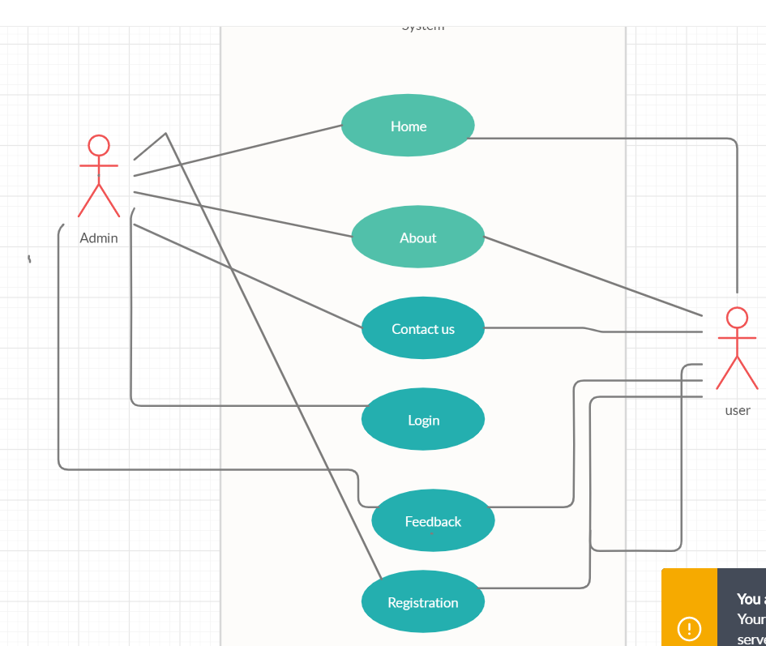

**Use Cases in above diagram are:**

1. **Home**
2. **About**
3. **Login**
4. **Contact us**
5. **Feedback**
6. **Registration**

**Actors in the above Diagram are:**

1. **Admin**
2. **Student**

**Wireframes:**

A wireframe is a schematic or blueprint that is useful for helping you, your programmers and designers think and communicate about the structure of the software or website you're building.  
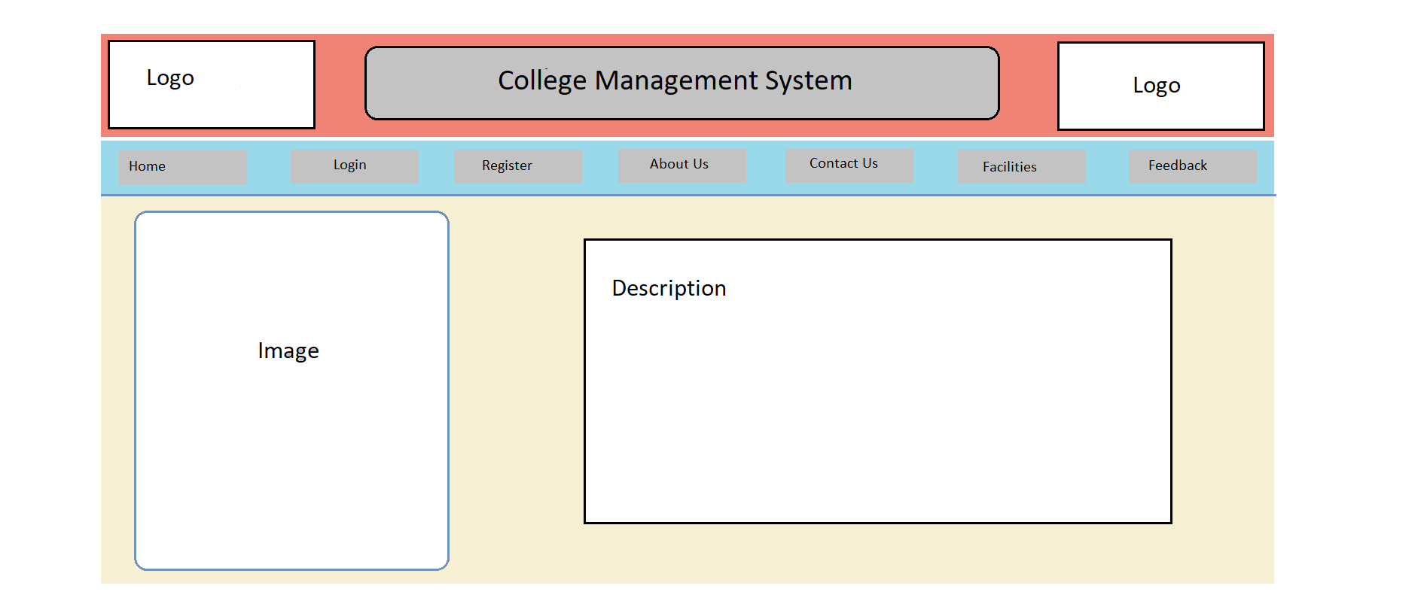

The following wireframe is having a title and image bars at the tops and we have a nav bar at the bottom of it where it has several sub pages like about, home, login, feedback, registration, contact us pages

RESULT Home Page:

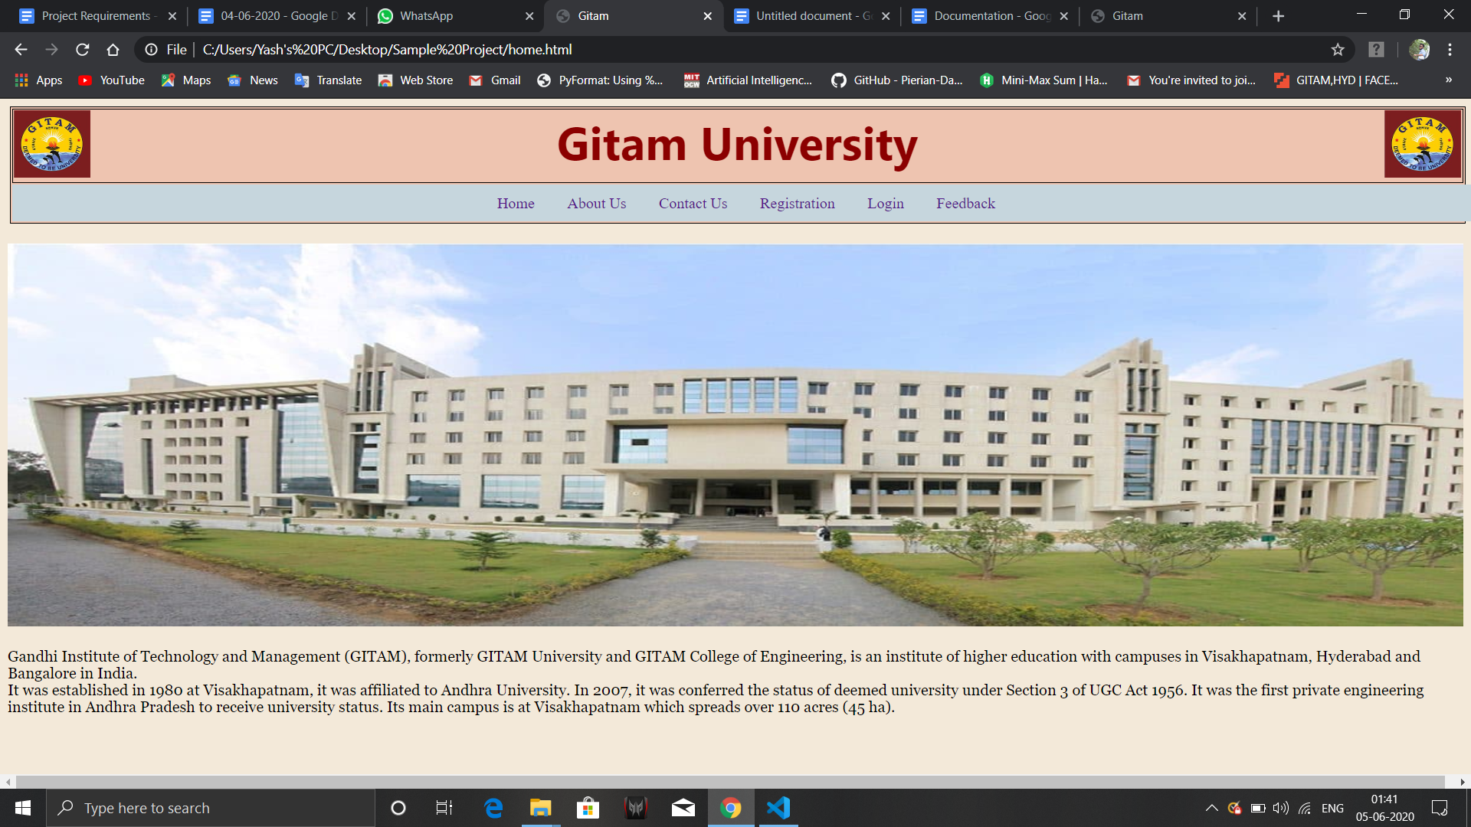

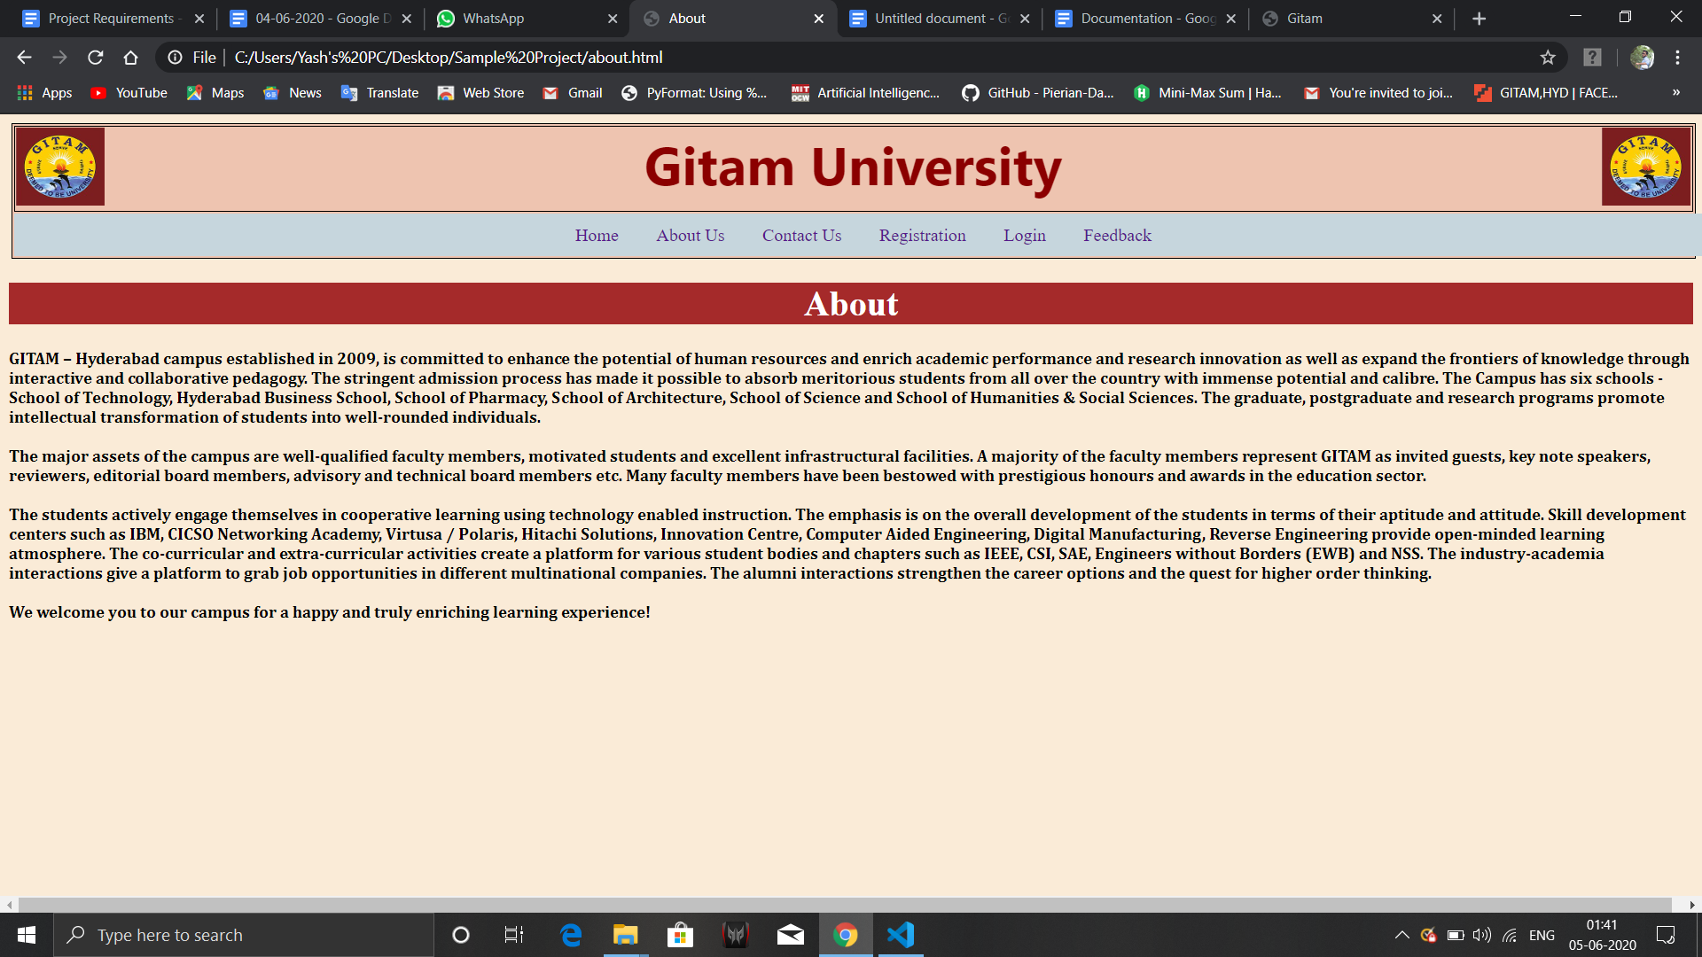

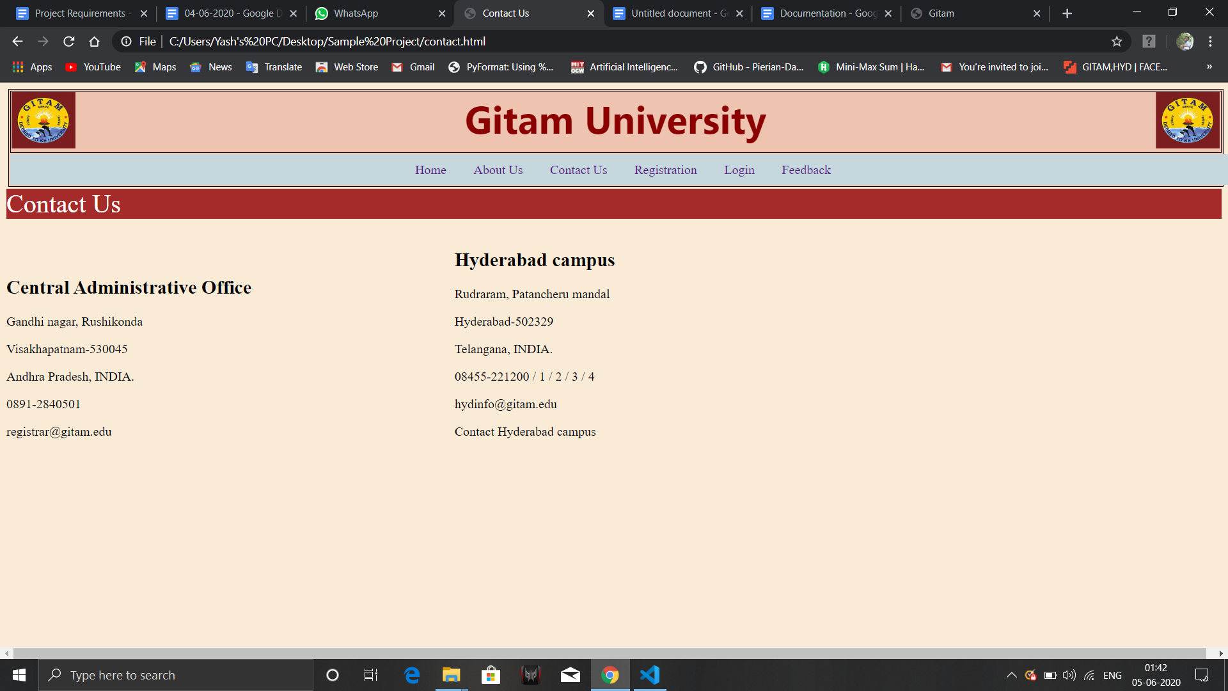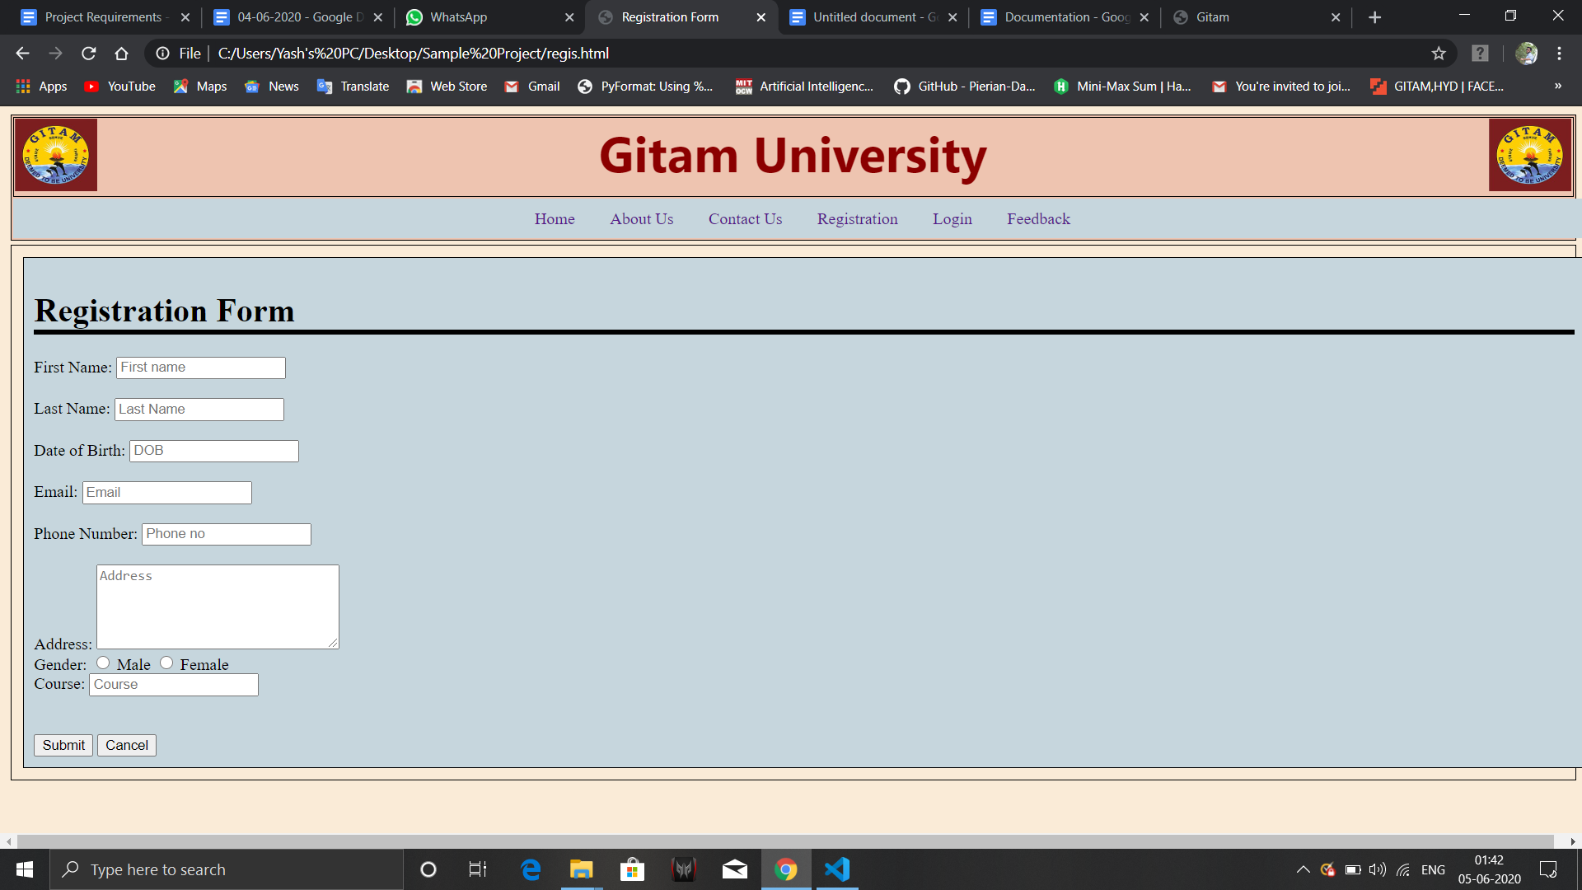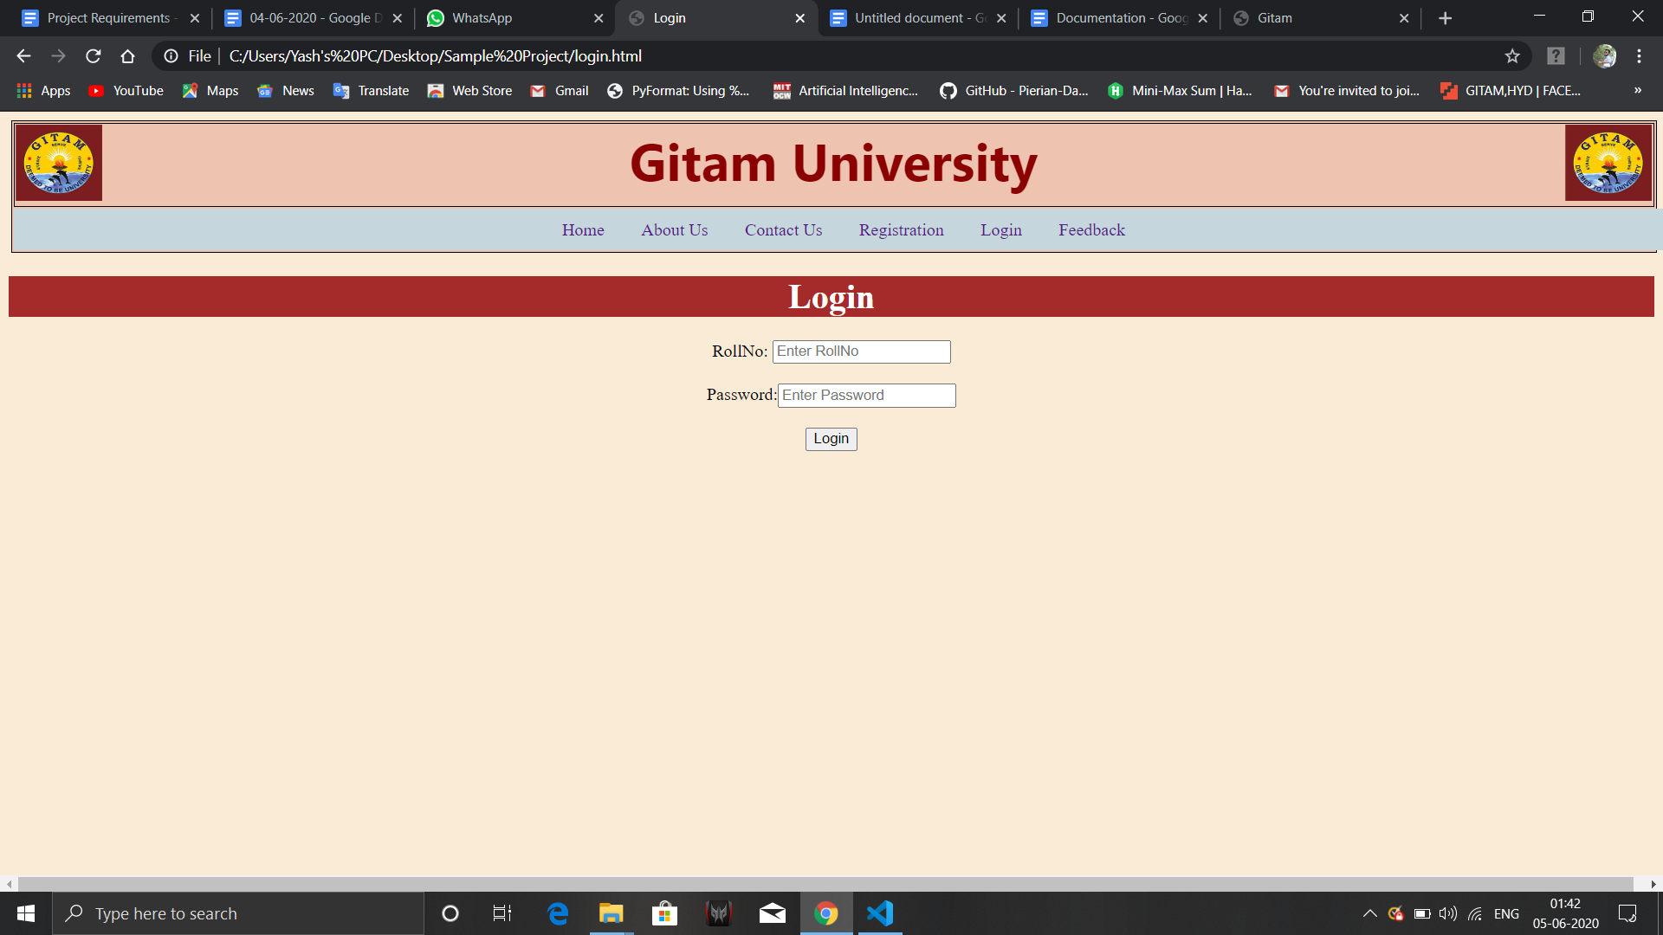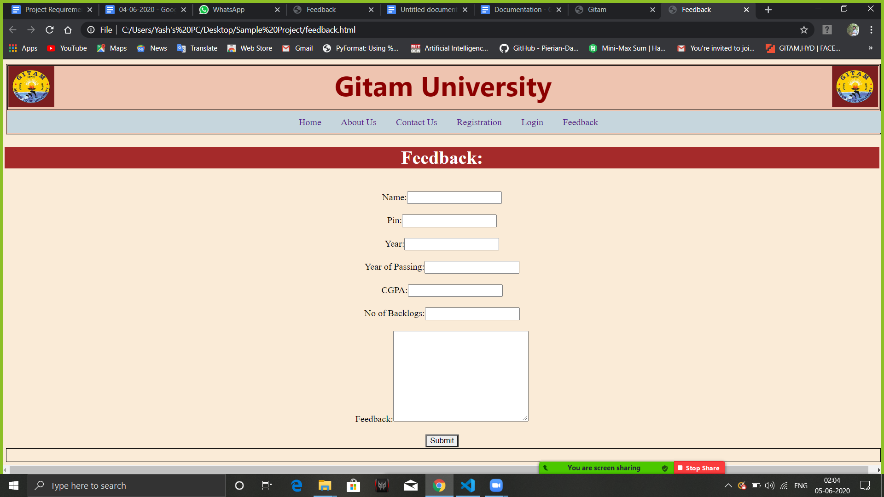

Conclusion:

The following page is totally useful for educational where it is useful for student and placement cell interaction purpose and get to know about placement cell of gitam